**3.4**

**Set up use permissions to filter information**

I have found it difficult to organise a buddy list in **Dropbox**, where I can use contacts to add to my sharing of files, the application uses a different method.

*To add fellow sharer’s, the owner must invite people they trust, to share individual files, by entering an e-mail address for each person sharing,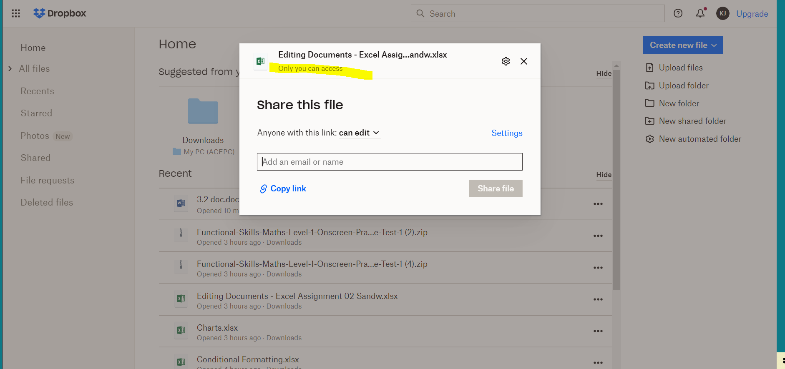*

*the owner can then give* ***different rights of access*** *to the file,*

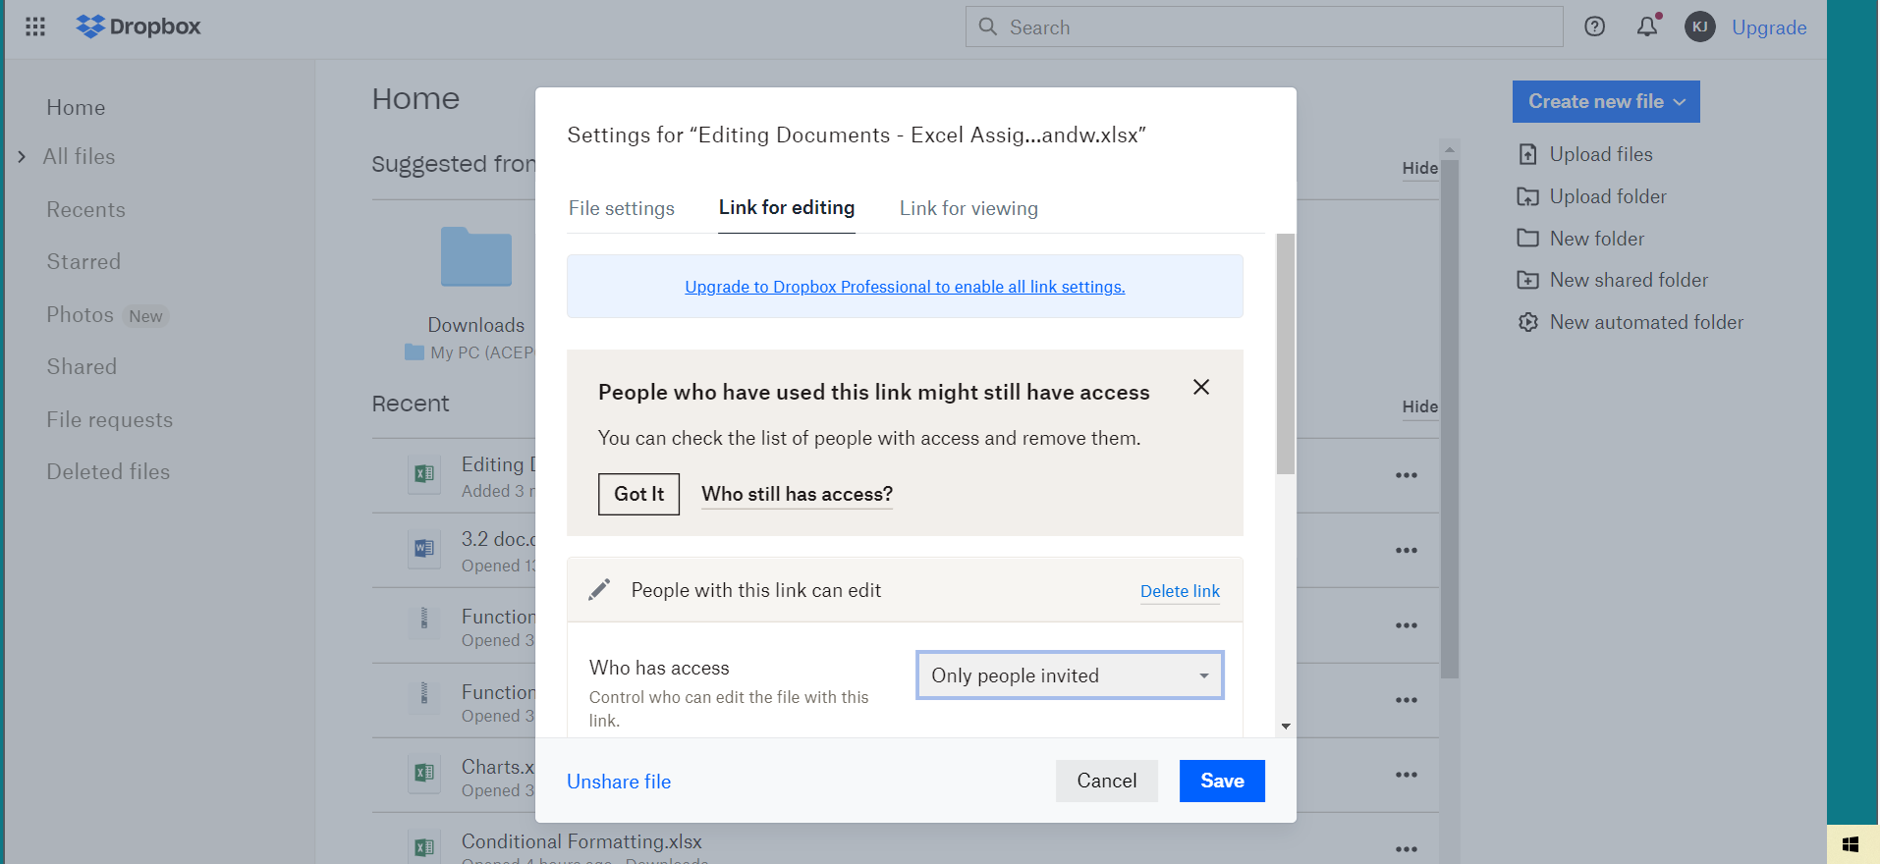*to the different individuals.*

*The owner can view who has access to the file and what right of access they have.*

*The new member who has been invited, receives an email from the owner, via Dropbox. With a link to the file*.